GOVERNMENT DEGREE COLLEGE, GUMMALAKSHMIPURAM
DEPARTMENT OF HISTORY 2024-25
Name of the Event: Pingali Venkayya Birth Anniversary
Guest of Honor : D. Ramaiah (Vice - Principal)
Date : 02-08-2024
Department : History
Lecturers Attended: 08
Students Attended: 30

Pingali venkayya birth anniversary 2024 the day celebrated in the college on 02-08-2024. The guest of honor was Sri D.Ramaiah garu Vice - Principal of the college, delivered a message pingali venkayya life history a was an Indian freedom fighter and the person behind the design of the Indian national flag. All staff members and students participated in this programme.
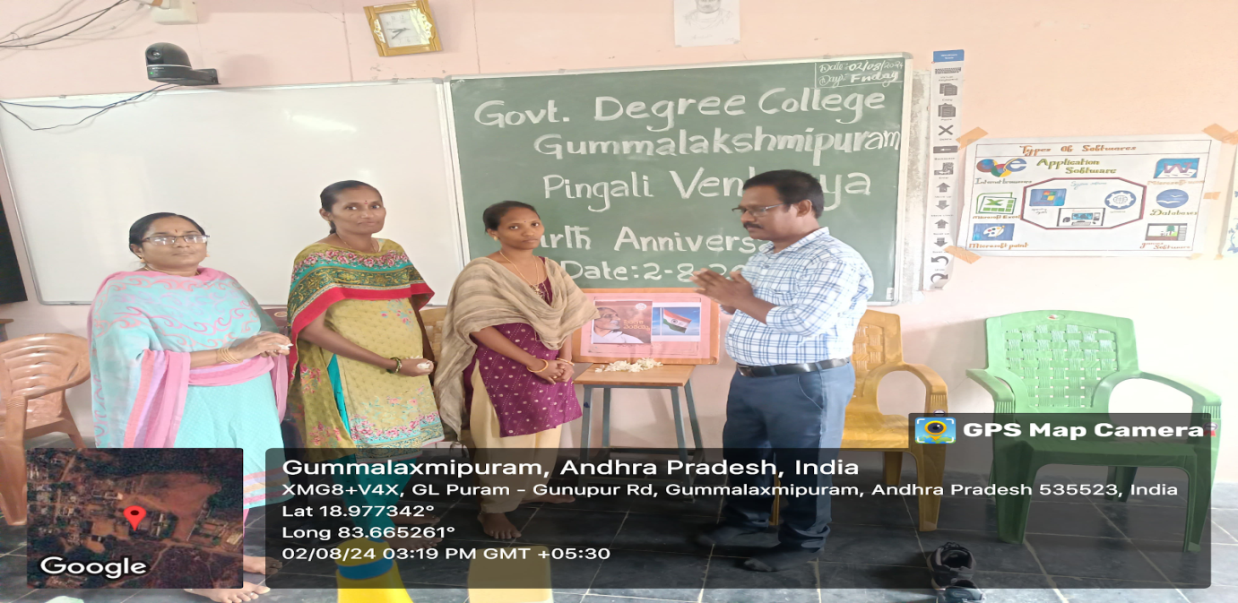

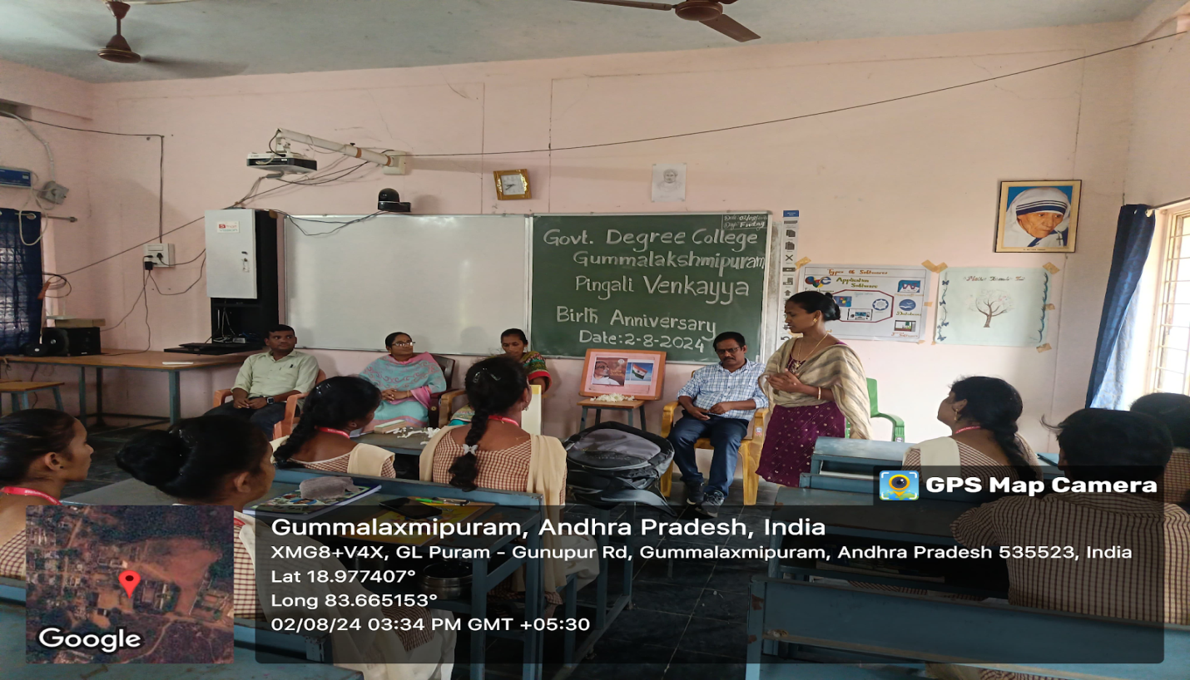
Speech Given by Lecturer in History A. Srivani
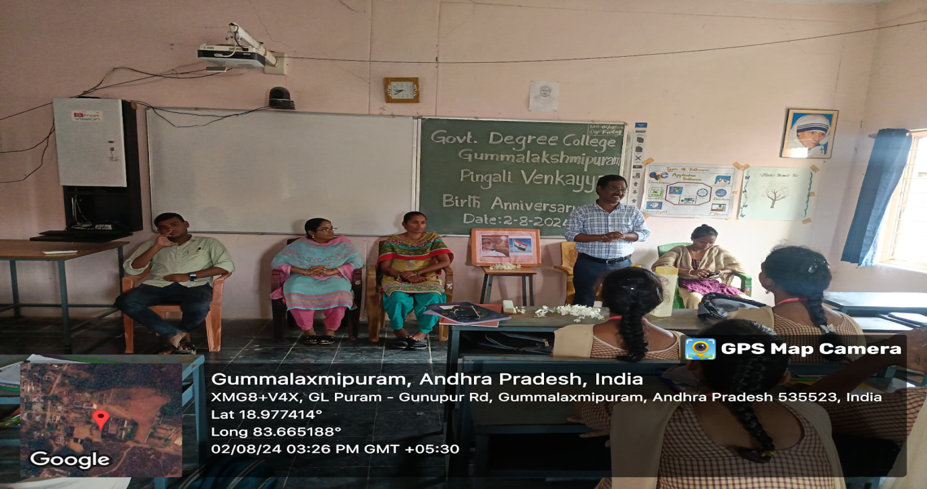 Speech given by In charge Principal D. Ramaiah
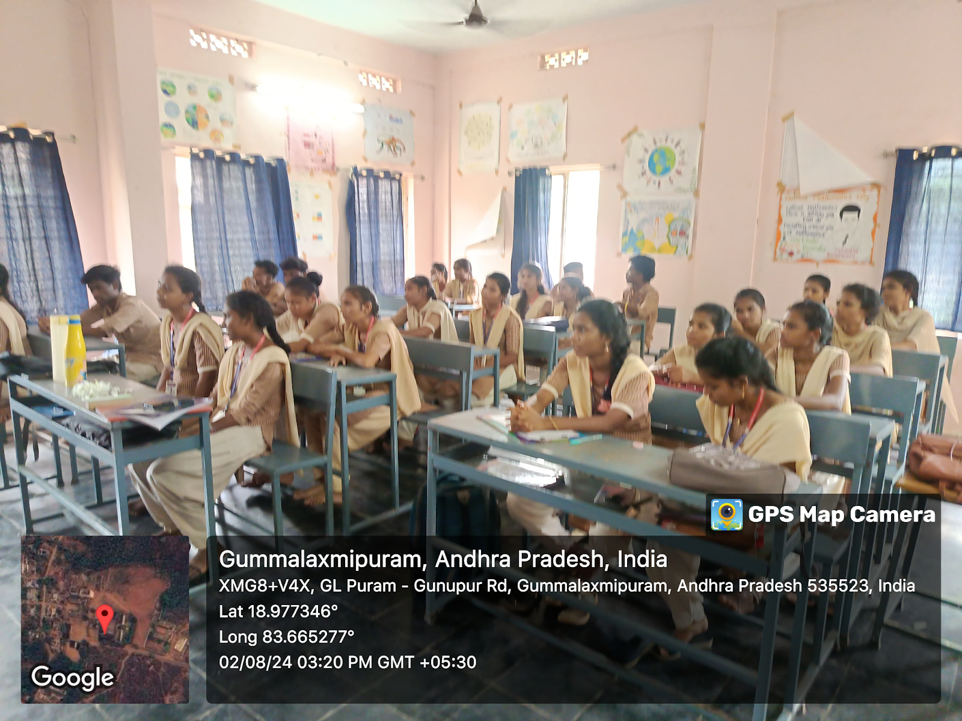
CONCLUSION
Pingali Venkayya's contribution to India’s independence is truly remarkable. As the designer of the Indian national flag, he gave the nation a powerful symbol of unity, freedom, and identity. His dedication to the country and his role in shaping its history should never be forgotten.
As we honor his legacy, let us remember that the flag he created is more than just fabric—it represents the sacrifices, dreams, and aspirations of a free India. Let us uphold the values of patriotism, unity, and progress that our flag stands for. May we always respect and cherish this symbol of our nation's pride.

Thank you.

